

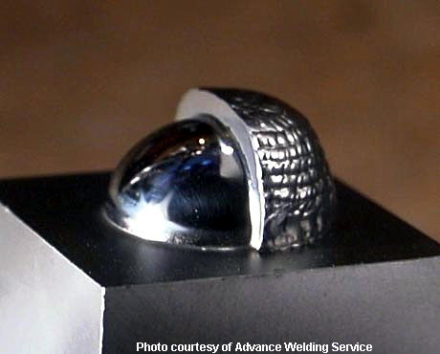

Surface Preparation can Make the Difference!!

Surface preparation can be the key to a successful weld. If a work surface is not prepared correctly welds can be contaminated, porous and crack sensitive. Along with preheating, cleaning is important to surface preparation. What is clean? How clean must a work piece be before welding? What about before other processes, such as the application of c.b.n.II? How can we remove contamination and still protect our work piece from oxidation? Nova Tech has a product for every cleaning need.

The degree of cleanliness necessary depends upon the processes that a piece will ultimately undergo. Welding requires that the surface be free of all oils, residues, dust, particles, films and fingerprints or, in cleaning terms - critically clean. EDMed surfaces may be coated with burned oils (hydrocarbons) and oxides, which, if present when welding, can contaminate the weld and render it more crack sensitive.

A surface may appear clean, visually, while still containing surface microcontamination. The application of c.b.n. II, Nova Tech’s Thermoelectric Control Cream requires a surface to be free of all surface protection as well as oils, particles, etc. A simple water-break test can ensure that these conditions are met. Pour water over the part and let it run off. If water beads on the surface, this indicates the presence of a coating (or surface protection), which would make the application of c.b.n.II difficult, if not impossible. If water sheets and flows off evenly, the surface is clean and ready for the application of c.b.n.II or welding.

The type of cleaning agent used determines the degree of cleanliness. Different products currently being sold by Nova Tech produce varying levels of cleanliness and are sold because of their unique properties. The delicate balance of protection from oxidation and rusting and critical cleanliness is one that demands constant attention.

NOVATECH
SYSTEMS FOR MICROWELDING

345 Farnum Pike, Smithfield, RI 02917-1205 800-442-NOVA 401-233-0010 401-233-0098 Fax

NOVATECH
SYSTEMS FOR MICROWELDING

345 Farnum Pike, Smithfield, RI 02917-1205 800-442-NOVA 401-233-0010 401-233-0098 Fax

